I have two reasons why I recommend the manuscript not be published.

REASON# 1 FOR REJECTION:

In the important '2 Methodology' section of the manuscript the authors wrote:

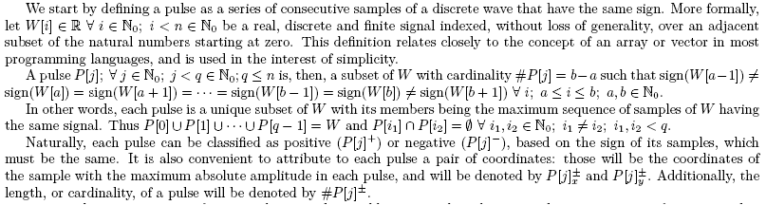

where the majority of the variables, and the nonstandard algebraic notation, in those paragraphs are undefined! The above four paragraphs look very professional and scholarly but they are the most confusing, overly complicated, difficult to understand definition of a pulse I have ever encountered in a DSP manuscript. I believe very few readers would read those paragraphs and then know what is a "pulse".

REASON# 2 FOR REJECTION:

Sprinkled throughout the manuscript is the following strange and unfamiliar terminology:

•roots of a continuous signal
•frontiers of a wave
•piecewise linear frontier
•superior and inferior frontiers
•cardinality of the frontier
•pseudo-cycles
•half cycle of a pulse
•a wave’s upper and lower boundaries
•the roots of a pulse
•delimitate a pseudo-cycle
•inferior space
•convex hull
•alpha-shapes
•atomic unit
•cardinality of a pulse
•discrete curvature
•vertices of a discrete wave,

Because the above terms were undefined by the authors I was unable to even begin to understand the envelope detection method presented in this manuscript.

The authors may well have a useful method for computing (estimating) the envelope of a discrete signal, but I can't be sure because I was unable to comprehend the technical content of this manuscript.

